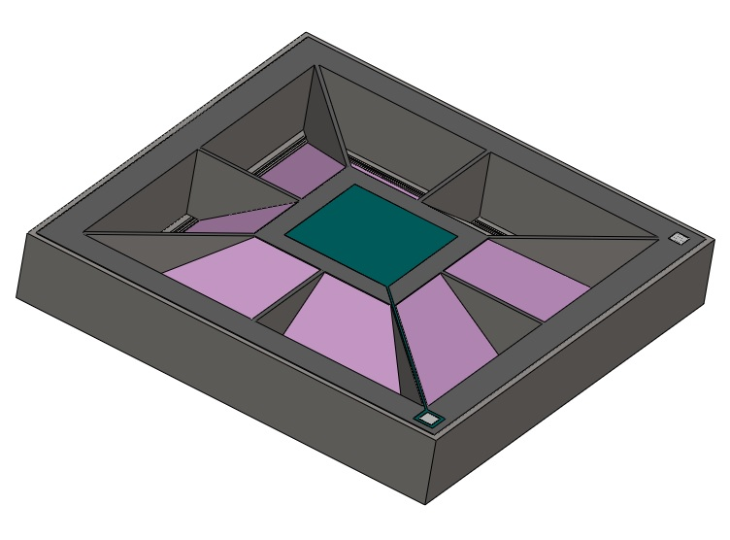
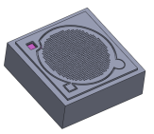
Part Number: DART-3868-1-0-1

The DOMS-AABB-F-X Product series of MEMS capacitive silicon microphones are patented advanced design microphones, developed and manufactured to cater to various customer applications and future requirements.

Capacitive sensing has been used in pressure sensor for many years. The transduction principle was adopted in MEMS based sensors in early 80s. Since then, it is widely accepted, and billions of units have been manufactured and distributed for various device applications.

In this design, capacitive sensing technology is taken to the next level in which a single platform technology is able to cater to a wide range of SNR from low -58dB to highest -70dB and more to meet the next wave of microphone requirement.

Unique patented designs and processes offer world class state of the art microphone for high volume and high-performance applications.

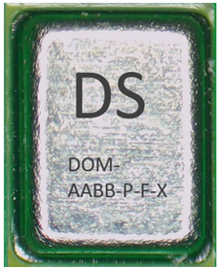

SENSOR FEATURES | PRODUCT FEATURES | APPLICATIONS
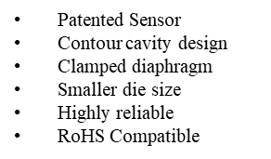 | 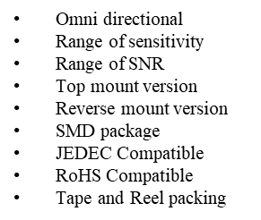 | 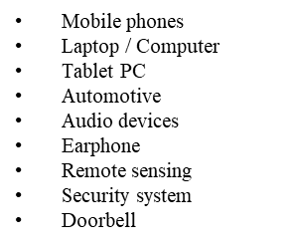

Technical Specification: All data taken at 25±2°C, Relative Humidity 45±5% unless otherwise specified.

GENERAL RATINGS SPECIFICTIONS

SPECIFICATION | MINIMUM | TYPICAL | MAXIMUM | UNITS
Operating Temperature | -40 | - | 100 | °C
Storage Temperature | -40 | - | 100 | °C

PRODUCT KEY ACOUSTIC PERFORMANCE SPECIFICATIONS

SPECIFICATION | MINIMUM | TYPICAL | MAXIMUM | CONDITION | UNITS
Low Frequency Roll-off | - | - | - | -3dB relative to @ 1KHz | Hz
High Frequency Flatness | - | 10 | - | +3dB relative to @ 1KHz | kHz
Resonant Frequency Peak | - | 39 | - |  | kHz
Sensitivity | -40 | -38 | -36 | 94 dB SPL @ 1kHz | dB V/Pa
SNR (Signal to Noise Ratio) |  | 68 |  | A-Weighted 100 | dB V/Pa
THD (Total Harmonic Distortion) | -  -  - | 0.01  0.1  1.0 | -  -  - | 94 dB SPL @ 1kHz  102 dB SPL @ 1kHz  112 dB SPL @ 1kHz | %
AOP (Acoustic Over Pressure) | - | >123 | - | 10% THD @ 1kHz | dB SPL

TYPICAL FREQUENCY RESPONSE CURVE

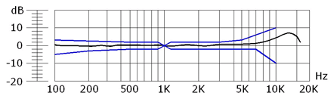

KEY ELECTRICAL CHARACTERISTIC AND PERFORMANCE

SPECIFICATION | MINIMUM | TYPICAL | MAXIMUM | CONDITION | UNITS
nput / Supply Voltage | 1.5 | 2.5 | 3.3 |  | V
Input current | 90 | 115 | 130 | Vdd=1.5V-3.3V | µA
Output impedance | - | 1 | 200 | 94 dB SPL @ 1kHz, Single-ended output | Ohm
Directivity |  | Unidirectional
PSRR | - | 90 | - | 200mVp-p sine wave at 1kHz, Vdd=1.8V | dB
DC output voltage |  | 0.85 |  | Vdd=1.5V-3.3V, Single ended output | V
Start-up time |  | 15 |  | Single-ended output | mS
Equivalent input noise |  | 3 |  | Noise measured with A-weighted filter | uV
PSR |  | -90 |  | 100mVp-p square wave at 217Hz, Vdd=1.8V, A-weighted | dB(A)SPL

ELECTRICAL PIN LAYOUT

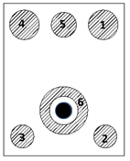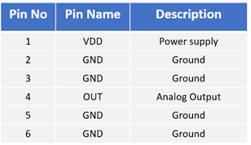

Bottom View

Terminology

- POWER: The Supply Voltage Positive Terminal (Pad name “VDD” in Electrical layout drawing) which is connected to the Microphone Sensing Element.
- OUTPUT: The Output Terminal, where the electrical signal equivalent to the acoustic pressure is available, i.e the Microphone output. (Pad name “OUTPUT” in Electrical layout drawing)
- COMMON: The Terminal where the supply negative (Pad name “GND” in Electrical layout drawing) is connected to microphone package.
- SENSITIVITY: Sensitivity is the open circuit output voltage amplitude for a given sound pressure at the microphone diaphragm. This is frequency dependent so typically quoted at 1KHz. Units are defined in dB logarithmic scale.
- FREQUENCY RESPONSE: It is the plot of Sensitivity in dB vs frequency [Hz], it depends on transducer mechanism directional response, and reflection from room boundaries – usually quote free-field response.
- DIRECTIVITY: It is the response pattern that expresses the geometric shape of the region of sensitivity surrounding the microphone, omni directional, uni directional, bi- directional.

ELECTRICAL BLOCK DIAGRAGM

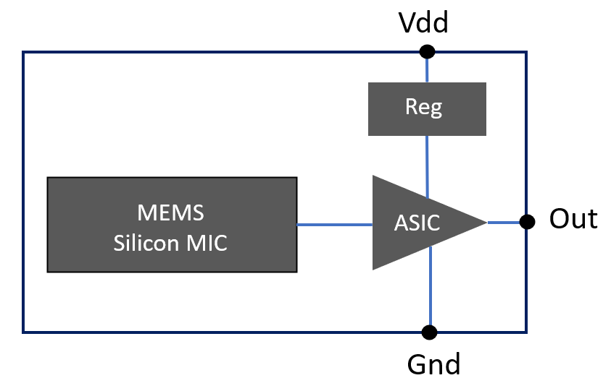
Functional block diagram

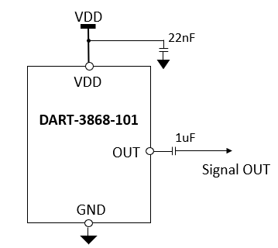

Application note

PACKAGE DIMENSION (Package Design 1)

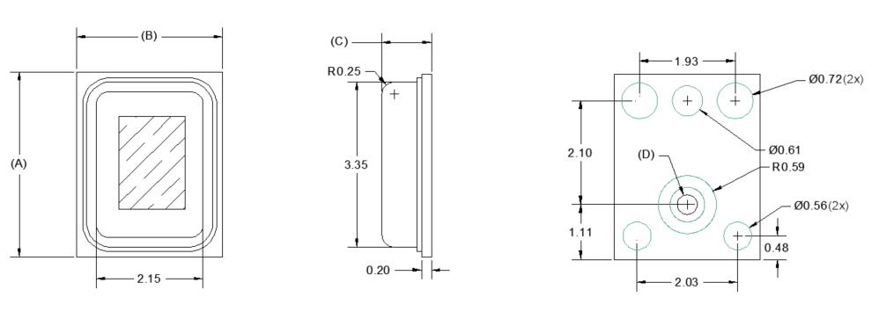

Top View Side View Bottom view

Item | Symbols | Dimension (mm)
Item | Symbols | Minimum | Nominal | Maximum
Length | A | 3.70 | 3.75 | 3.80
Width | B | 2.90 | 2.95 | 3.00
Height | C | 0.90 | 1.0 | 1.1
Acoustic Port Hole Diameter at PCB | D | 0.35 | 0.4 | 0.45
Acoustic Port Hole Diameter at CAP | D | - | - | -

Note:
* All dimensions are in millimeters (mm)
* Tolerance ±0.10 mm unless specified

SHIPPING OPTION

Tape & Reel
A. Reel Diameter: 13”
B. Quantity / Reel: 4,500 pieces
Trailer
Leader
248mm
32 units
4500 units
63 units
Microphone
Cover Tape
9.3mm

A
C
B
D
E
F
G

Description | Symbol | Dimension (mm)
Description | Symbol | Minimum | Nominal | Maximum
Reel Diameter | A | - | 330 | -
Hub Diameter | B | 98 | 100 | 102
Hub Hole Diameter | C | 12.8 | 13 | 13.5
Reel width (measured at hub) | D | - | 18 | 18.4
Arbor Hole | E | 20.2 | - | -
Arbor Hw in mm Diameter | F | 12.8 | 13.0 | 13.5
Arbor Slot Width | G | 1.5 | - | -

CARRIER TAPE DIMENSIONS

SYMBOLS | MILLIMETER
SYMBOLS | MINIMUM | NOMINAL | MAXIMUM
T | 0.250 | 0.300 | 0.350
Ao | 4.000 | 4.100 | 4.200
Bo | 6.300 | 6.400 | 6.500
Ø Do | 1.450 | 1.500 | 1.550
Ø D1 | 1.500 | 1.500 | 1.700
E1 | 1.650 | 1.750 | 1.850
F | 5.400 | 5.500 | 5.600
Ko | 1.650 | 1.750 | 1.850
Po | 3.900 | 4.000 | 4.100
P1 | 7.900 | 8.000 | 8.100
P2 | 1.900 | 2.000 | 2.100
Ro | - | 0.300 | -
W | 11.700 | 12.000 | 12.300

PACKING INFORMATION

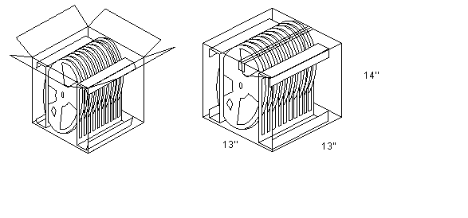

Qty/reel  (pcs) | Weight/reel (kg) | Reel/carton  (nos) | Weight full load (kg) | Dimension carton box | Storage  (Temp)
4500 | 4.50 | 10 | 47 | 13” x 13” x 14” | -10ºC ~ 50º C

REFLOW PROFILE

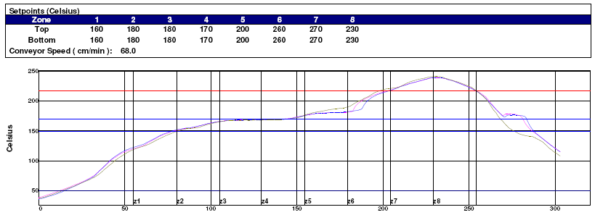

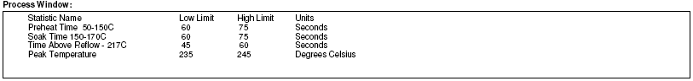

MICROPHONE SENSITIVITY TEST SET UP

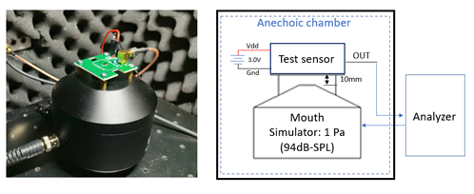
Near field artificial mouth Test setup. The sound pressure at Mouth reference position 25.4mm in front of the lip ring of a mouth simulator is maintained constant over the frequency range of measurement at a level of 0dBPa.

RELIABILITY TEST CONDITIONS

- Temperature characteristics: Data collected at -40°C, +25°C, +85°C.
- Temperature shock: 32 cycles, starting from cold to hot temperatures. Each cycle: 30mins at -40°C followed by 30mins at +85°C with a 20s max transition time.
- Static humidity: Precondition @+25°C for 1hr. Expose to +70°C with 90-95% RH for 240hrs. Dry at room ambient for 4hrs before measurements.
- Random vibrations: Vibrate randomly from 20-2000Hz using the following power Spectra Density (PSD) profile: It is a +3dB/octave from 20-80Hz, then 0.053g2/Hz or at 8g’s RMS level from 80 -350Hz, and finally at -3dB/octave from 350-2000Hz. The PSD tolerance is +/-3dB from 20-1000Hz and +/-6dB above 1000Hz. The Analyzer Bandwidth to be set at 25Hz BW from 20-200Hz, 50Hz BW to 1000Hz, and finally 100Hz BW to 2000Hz. The test time is 15 mins per plane.
- Mechanical shock: Subject samples to three one-half sine shock pulses (3000g’s for 0.3ms) in each direction (for six totals) along each of the three mutually perpendicular axes for a total of 18 shocks.
- Operation life: Subject to 85°C for 1000hrs under full rated power.
- Solder heat resistance: 3x reflow @ 230°C and 260°C.

DELIVERY STANDARD:

- Product delivered with 100% tested.
- Product tested 100% for Sensitivity @ 1KHz
- Product samples tested for Frequency curve and SNR

STANDARD TERMS AND CONDITIONS:

- Method of shipping (FOB/CIF/COD) can be negotiable.
- Payment terms and conditions negotiable.

NOTE:

SOME OF THE PARAMETERS ARE SUBJECT TO CHANGE

PRODUCT NAMING CONVENTION

PROD

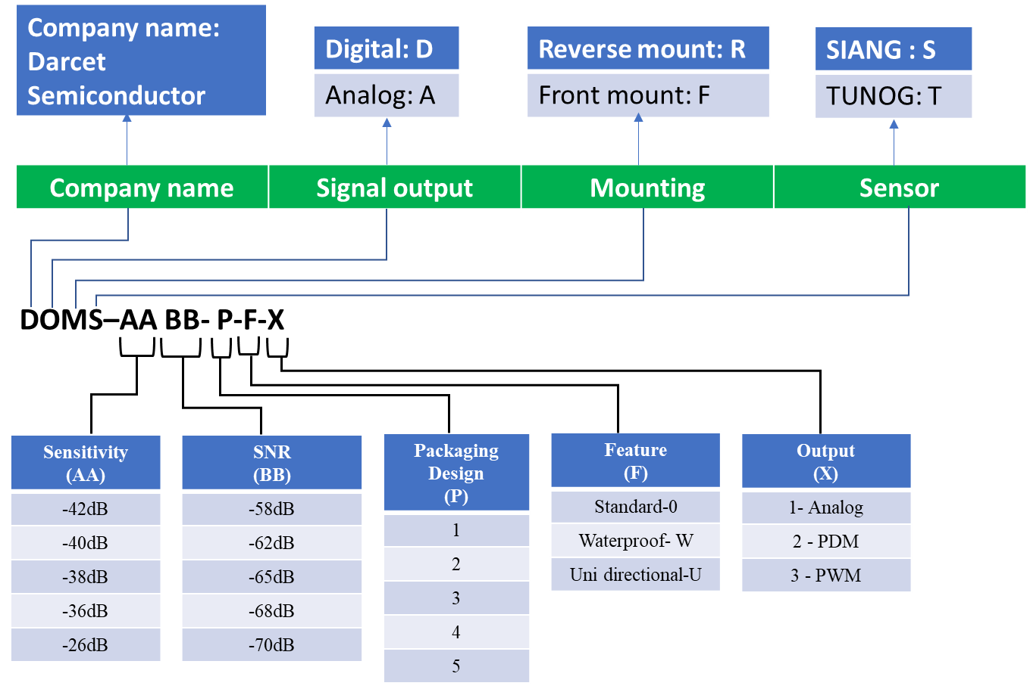

ORDERING CONTACT INFORMATION

KOREA
Kingly Bang
Address:
Phone number: +821039081701
Email address: kingly@darcet.com.cn

CHINA
Jane Soh
Address: 1st Floor West Wing, Building 30, No.18
Dongchang, Suzhou Industrial Park,
Suzhou,215000, China.
Phone number: +8613236448283
Email address: jane@darcet.com.cn

SINGAPORE
Anu Austin
Address: 50, Macpherson Road,
#07-01 Amazana Road
Singapore-348471
Phone number: +65 96235457
Email address: anu.austin@innogritysg.com

EUROPE
Dieter Nagalae
Address: Heimesgasse 19d,
Ingelheim am Rhein-55218
Phone number: +4915253923397
Email address: dieter@darcet.com.cn

NORTH AMERICA
Sempian Sooriakumar
Address: 75 Boniface Drive
Rochester, NY 14620
Phone number: +1 5854695508
Email address: sempian@darcet.com.cn

